

|  |
| --- |
| **LAB 1** of DSA LAB |

**Submitted by:**

**Name:** Muhammad shuraim

**Roll no:** SU92-S24-BSSEM-103

**Section:** 3A

**Submitted to**

Sir Rasikh Ali

**Question 1**

#include<iostream>

using namespace std;

int main() {

int num=10;

int*ptr=& num ;

cout << "Before Modify :" <<endl;

cout << "num ="<<num << endl;

cout << "ADRESS :" << ptr << endl;

cout << "Value :" <<*ptr<< endl;

*ptr = 50;

cout << "After Modify :"<<endl;

cout << "num =" << num << endl;

cout << "ADRESS :" << ptr << endl;

cout << "Value :" << *ptr << endl;

return 0;

}

**OUTPUT**

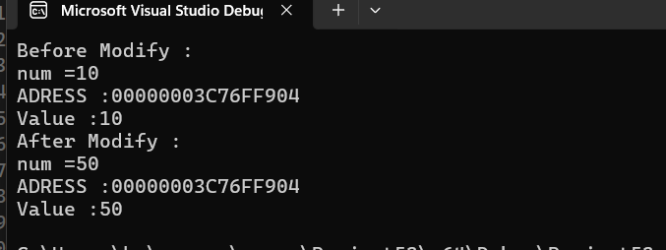

Explanation

* Declare Num As Integer(int num=10)
* Declare Pointer ptr And Assign The Adress Of Num(int *ptr=&num)
* Use The Pointer To Modify Num(*ptr=50)
* Display Values Before And After